Sammy’s Dog Walking Service Agreement
Dog Walking & Dog Boarding – Charlottesville and surrounding area for Albemarle County
434-547-3453 - sammyswale@gmail.com
sammysdogwalking.com – Charlottesville, VA

Name_____________________________ Email Address ________________________________________
Home Phone _______________________ Cell Phone_____________________________
Work Phone _______________________ Employer _____________________________
Home Address __________________________________________________________________
Emergency Contact
Please circle yes or no if they have a copy of your house key. They should be able to make a decision about the care of your pets or home if we cannot reach you in case of an emergency.

Name ___________________________ Relation______________ Phone__________ Key Y/N

Veterinary Information
Name of hospital ______________________________________________________________

Preferred Doctor_______________________________________________________________
Pet #1 Information
Name ___________________________ Color: ________________________________
Breed: __________________________________ Pet Date of Birth: _______________
Pet #2 Information
Name ______________________ Color: ________________________________
Breed: __________________________________ Pet Date of Birth: _______________

Pet #3 Information
Name ______________________ Color: ________________________________
Breed: __________________________________ Pet Date of Birth: _______________

Please read the Terms and Conditions and sign:

Meet and Greet: The first step in starting dog walking and dog boarding is a meet and greet. During this appointment, we will meet with you and your pets and discuss how we can best meet your needs. The appointment normally lasts about 30 minutes and costs $15. We look forward to meeting with you!

**ALL DOGS OVER 6 MONTHS OLD WE BOARD MUST BE NEUTERED OR SPAYED**

Holidays for Dog Walking: Easter, Memorial Day Weekend (5/27-29), July 4, Labor Day Monday, Thanksgiving (Nov 24 – Nov 27), December 24 – January 1
Holidays for Dog Boarding: Easter, Memorial Day Weekend (5/27-29), July 4, Labor Day Weekend, Thanksgiving (Nov 24 – Nov 27), December 24 - January 1

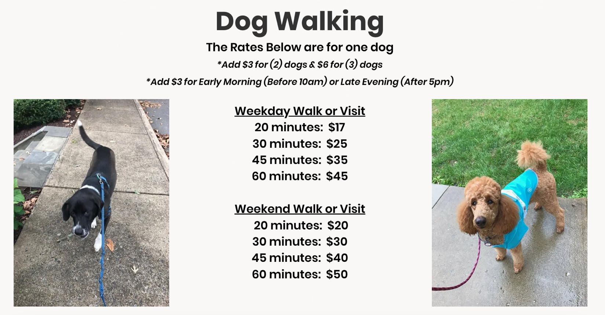
Dog Boarding at YOUR House: $75 (add $5 for a second dog)

**Dog Walking Hours: 8:00am – 6:30*
**All steady clients pay normal rates except on actual holiday**

If a client requests a dog-run or visit to the dog park, Sammy’s Dog Walking LLC does not accept or assume responsibility if your dog or dogs are bitten or attacked in any way, shape or form from another dog.

Last Walks of The Day
6:30pm – all year long

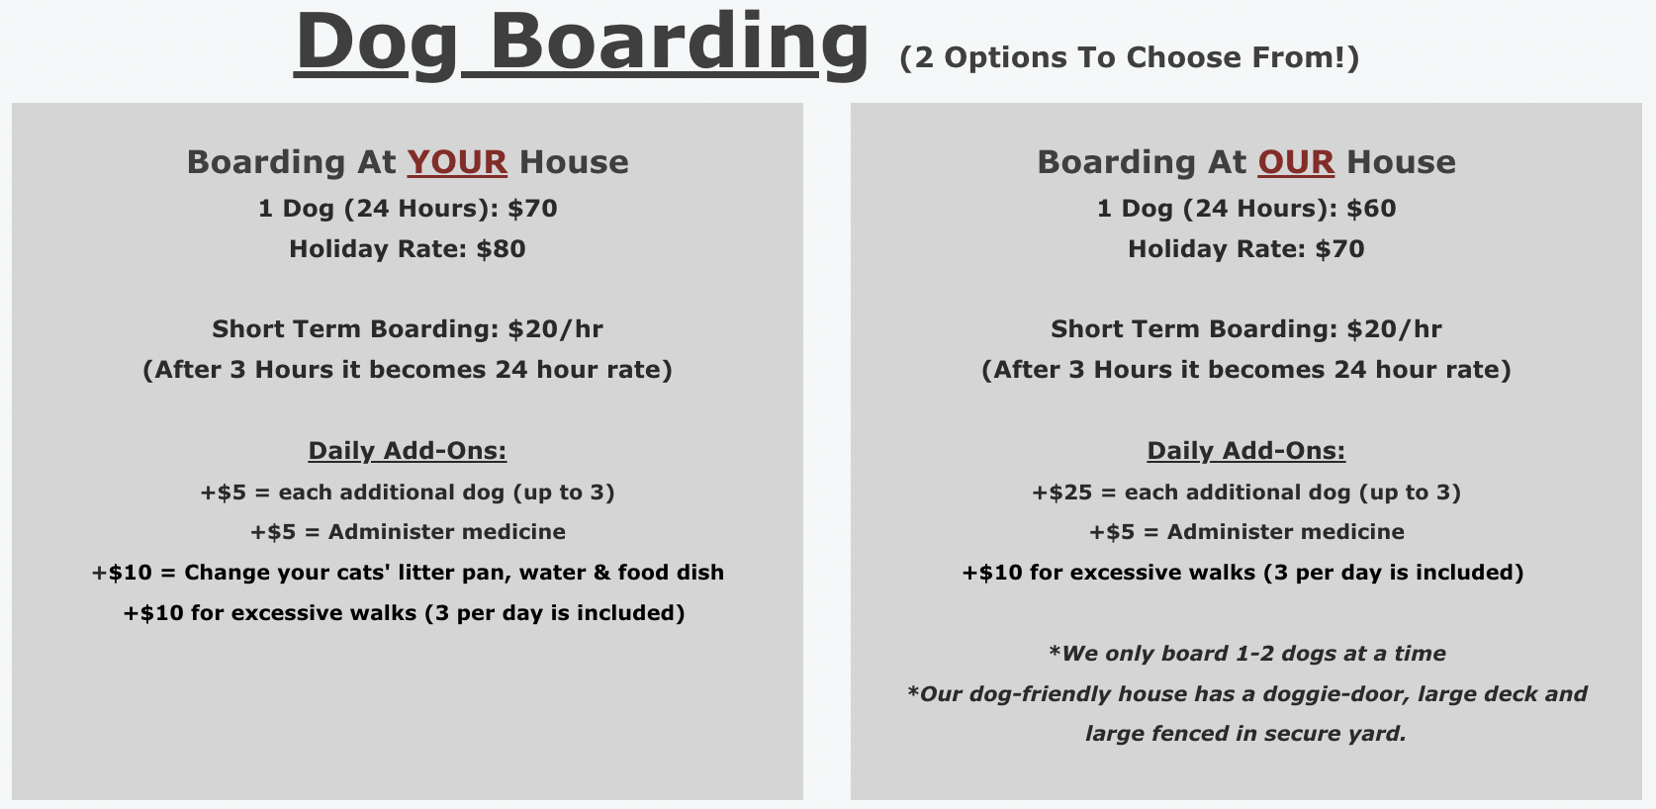

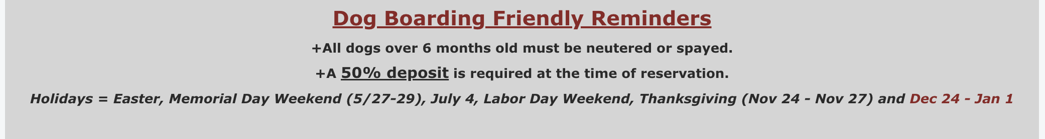
Dear Valued Customers –
Thank you for your continued service and support of Sammy’s Dog Walking. We wanted to let you know of an update to our policy. Holidays (Thanksgiving, Christmas, Memorial Day (5/27-29), July 4th and Easter Break) tend to be a very busy time for our pet sitting business and we often have to turn away customers because we don’t have enough staff to accommodate all of the requests. Unfortunately, over the past year, far too many of these scheduled dates have ended up cancelling at the last minute, not only causing us to lose out on needed and planned revenue, but other valued clients to miss a chance for services that we could have provided to them instead.
As a result, the company has been forced to implement a 50% non-refundable cancellation policy upon commitment to one of our pet sitting engagements. This ensures that your spot is held and encourages a serious desire to follow-thru as planned. Again, thank you for your continued business and we look forward to spending time with your beloved fur babies.
Dog Transportation Services: We can pick up and bring your dog to daycare, vet visits or anywhere else around town. We love walking dogs - one-way trips during the week are $25 and weekend trips (if available) are $30 one-way.

Cat Care: One of our team members will stop by to scoop the litter box, put out fresh food and water and provide plenty of love and attention. Visits typically last 20 minutes. While there, we can also water plants and bring in the mail. We charge $15 for weekday visits and $20 for weekend visits. Add $3 for 4 or more cats.

Cancellation Policy: Our cancellation policy is in place because we highly value our professional dog walkers' time and personal commitments outside of Sammy's Dog Walking Service. Please read our cancellation policy carefully:
A 24-hour advance notice is required for cancellations on all days in order to receive a full credit towards future services. If a cancellation has not been submitted and our walker arrives at your home to provide care, your account will be charged for the full amount.

Inclement Weather Policy: Whether it’s a blizzard outside or scorching hot, Sammy's Dog Walking may adjust the walks and routes based on current conditions. On days with extreme weather the walks may be shortened to ensure the safety of our dogs and walkers. However, due to the risks associated with walking dogs in extreme conditions, rates are not changed due to shortened walks.
In addition, Sammy's Dog Walking retains the right to cancel service due to inclement weather that we deem hazardous or dangerous up to the day of service. Sammy's Dog Walking will notify the clients as soon as possible for all cancellations.

For the safety of our walkers, no dog walks after 8:00 pm

For Clients Off The Beaten Path: We serve clients throughout Charlottesville and Albemarle County. We are happy to serve clients throughout Albemarle County even if it means a longer commute and increased gas expenses for our walkers. In order to cover the cost we add $3.00 to each walk if clients live north of Hollymead Town Center or south of Old Lynchburg Road. In addition, clients in Earlysville, Free Union, Ruckersville, Standardsville and those south of the Mill Creek North neighborhood as well as those past will pay $3.00 extra for each walk.

Changes in Dog Walkers: If we need to have a different walker for your pet, you will be notified beforehand in the event you would like to meet them. A picture and bio of all of our walkers can be found on our website. All of our dog friendly walkers are bonded and insured.

Unexpected Accidents: Occasionally when we arrive at a clients house, our furry friend has had an accident in their crate or in the house. Rather than leave the accident inside the crate or on the floor, our walkers diligently clean up which may result in slightly longer times at the house & higher rates. This policy also applies to similar tasks such as putting on diapers (IE a 20 minute walk can end up being 30 minutes)

Acknowledged and agreed to by:

Signature: _____________________________________

Printed name: __________________________________ Date: ________________

Please make a copy of this contract for your records.

Thank you for your business!

